ID: 22424212
COMPUTATIONAL STATISTICS EXAM (ASTA 607)

QUESTION ONE(a)
The crabs data frame consists of the Morphological Measurements on Leptograpsus Crabs with 200 rows and 8 columns, describing 5 morphological measurements on 50 crabs each of two colour forms and both sexes, of the species Leptograpsus variegatus. The data frame was collected at Fremantle, W. Australia for a multivariate study of variation in two species of rock crab of genus Leptograpsus by Campbell, N.A and Mahon, R.J in 1974.
QUESTION ONE(b)
#Loading the dataset
Code:
crabs
head(crabs)

Output:
sp sex index FL RW CL CW BD
1 B M 1 8.1 6.7 16.1 19.0 7.0
2 B M 2 8.8 7.7 18.1 20.8 7.4
3 B M 3 9.2 7.8 19.0 22.4 7.7
4 B M 4 9.6 7.9 20.1 23.1 8.2
5 B M 5 9.8 8.0 20.3 23.0 8.2
6 B M 6 10.8 9.0 23.0 26.5 9.8

#Structure of the dataset
Code:
str(crabs)

Output:
'data.frame': 200 obs. of 8 variables:
$ sp : Factor w/ 2 levels "B","O": 1 1 1 1 1 1 1 1 1 1 ...
$ sex : Factor w/ 2 levels "F","M": 2 2 2 2 2 2 2 2 2 2 ...
$ index: int 1 2 3 4 5 6 7 8 9 10 ...
$ FL : num 8.1 8.8 9.2 9.6 9.8 10.8 11.1 11.6 11.8 11.8 ...
$ RW : num 6.7 7.7 7.8 7.9 8 9 9.9 9.1 9.6 10.5 ...
$ CL : num 16.1 18.1 19 20.1 20.3 23 23.8 24.5 24.2 25.2 ...
$ CW : num 19 20.8 22.4 23.1 23 26.5 27.1 28.4 27.8 29.3 ...
$ BD : num 7 7.4 7.7 8.2 8.2 9.8 9.8 10.4 9.7 10.3 ...
>

Interpretation:
The crabs data is a data frame with 200 observations and 8 variables.
The variables and their types in the data frame are:
- Species - factor
- Sex - factor
- Index - integer
- Frontal Lobe size (mm) - numeric
- Rear Width (mm) - numeric
- Carapace Width (mm) - numeric
- Body Depth (mm) – numeric
QUESTION ONE(c)
#Frequency table for species
Code:
crab_species<-factor(x=crabs$sp, labels = c("Blue", "Orange"))
species_table<-table(crab_species)

Output:
crab_species
Blue Orange
100 100

Interpretation:
The frequency table displays 100 blue crab species and 100 orange crab species
#Frequency table for sex
Code:
crab_sex<-factor(x=crabs$sex, labels = c("Female", "Male"))
sex_table<-table(crab_sex)

Output:
Female Male
100 100

Interpretation:
The frequency table displays 100 female crabs and 100 male crabs.

QUESTION ONE(d)
#Code:
barplot(species_table,main = "Bar chart of Crab species", ylab = "Species",
xlab = "Frequency", col=c("purple","pink"))

#Barplot for Group composition - Species
Output:
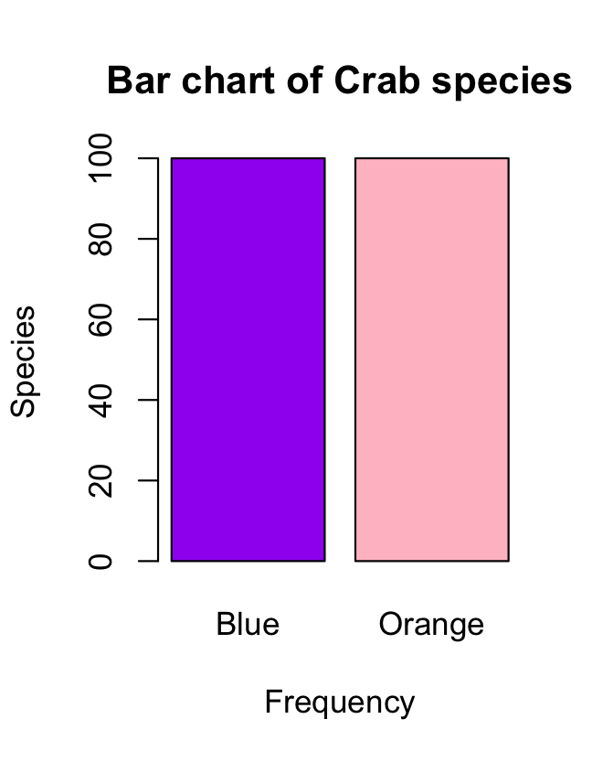

Interpretation:
The number of blue and orange species are the same.

#Barplot for Group composition - Sex
Code:
barplot(sex_table,main = "Bar chart of Crab Sex", ylab = "Sex",
xlab = "Frequency", col=c("blue","yellow"))

Output:
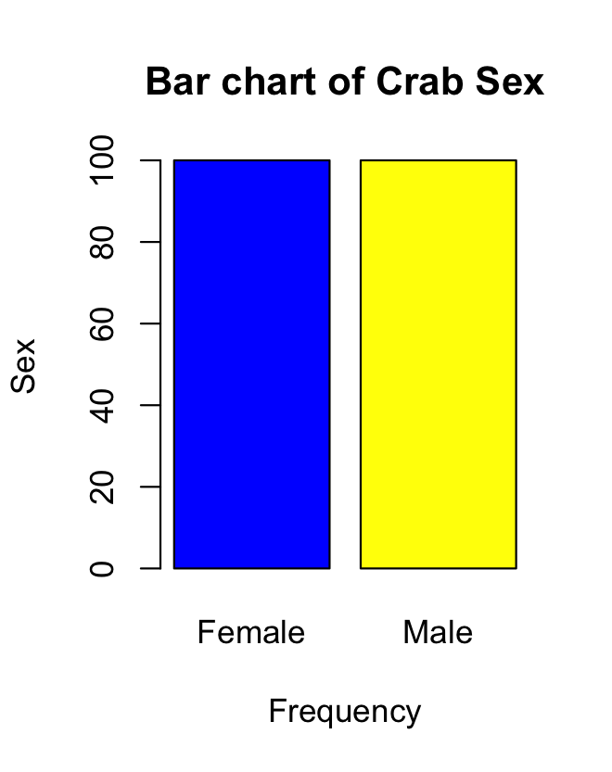

Interpretation:
The number of female and male species are the same.

QUESTION ONE(e)
The dataset is balanced amongst the four groups because the species are divided into equal parts as well as the sex this helps with statistical analysis.

QUESTION TWO (a)
#Side-By-Side boxplot of body depth for the four groups by species and sex
Code:
crabs$sp<-crab_species
crabs$sex<-crab_sex
par(mfrow = c(1,2))
boxplot(BD~sp, data = crabs,col=c("purple","pink") )
boxplot(BD~sex, data = crabs,col=c("blue","yellow") )

Output:
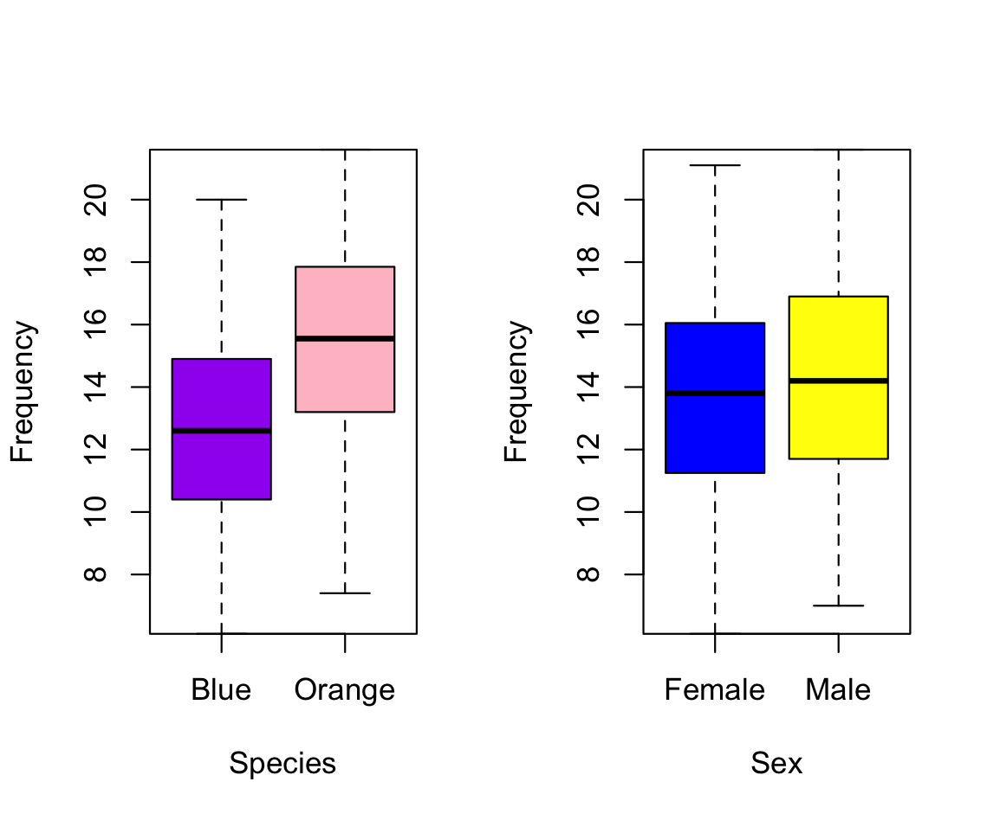

QUESTION TWO (b)
Species
There are zero to no outliers. The blue and orange crabs are both widely spread. The median is also in the center which implies that the distribution of the species are approximately normal.
Sex
There are zero to no outliers. The female and male crabs are both widely spread. The median is also in the center which implies that the distribution of the sex is approximately normal.

QUESTION THREE (a)
#Histogram for each species
Code:
par(mfrow = c(1,2))
hist(x=crabs$CL[crabs == "Blue"], xlab = "Blue Crabs",
ylab = "Length in (mm)", col = "blue",
main = " Carapace Length of Blue Crabs")

hist(x=crabs$CL[crabs == "Orange"],xlab = "Orange Crabs",
ylab = "Length in (mm)",col = "orange",
main = " Carapace Length of Orange Crabs")

Output:
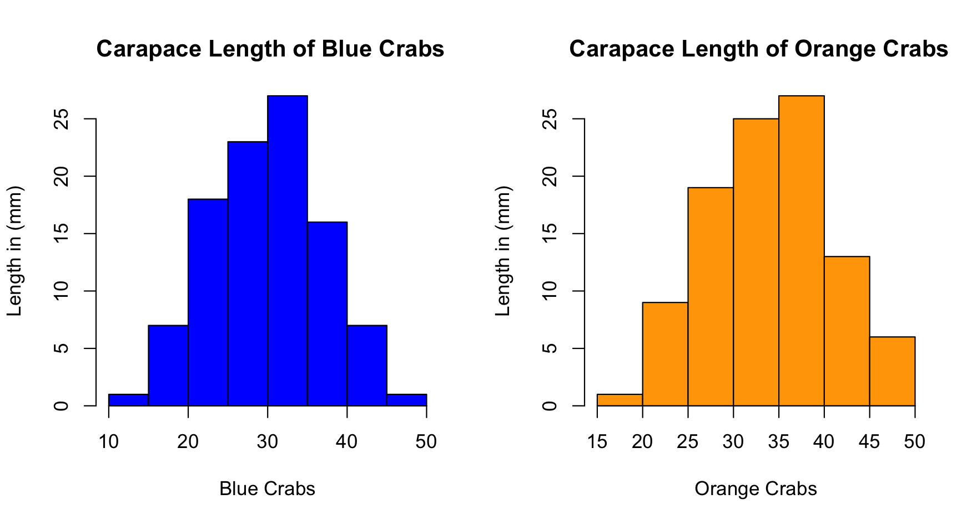

QUESTION THREE (b)
Blue Crabs
The carapace length for blue crabs are approximately normally distributed with a single mode of.
Orange Crabs
The carapace length for orange crabs is a bit skewed to the left with a single mode.

QUESTION FOUR (a)
#Mean of each morphological measurement by species
Code:
mean_by_species<-crabs %>%
group_by(sp) %>%
summarise(
mean_FL = mean(FL),
mean_RW = mean(RW),
mean_CL = mean(CL),
mean_CW = mean(CW),
mean_BD = mean(BD)
)

Output:
sp mean_FL mean_RW mean_CL mean_CW mean_BD
<fct> <dbl> <dbl> <dbl> <dbl> <dbl>
1 Blue 14.1 11.9 30.1 34.7 12.6
2 Orange 17.1 13.5 34.2 38.1 15.5
>

#Mean of each morphological measurement by sex
Code:
mean_by_sex<-crabs %>%
group_by(sex) %>%
summarise(
mean_FL = mean(FL),
mean_RW = mean(RW),
mean_CL = mean(CL),
mean_CW = mean(CW),
mean_BD = mean(BD)
)

Output:
sex mean_FL mean_RW mean_CL mean_CW mean_BD
<fct> <dbl> <dbl> <dbl> <dbl> <dbl>
1 Female 15.4 13.5 31.4 35.8 13.7
2 Male 15.7 12.0 32.9 37.0 14.3

QUESTION FOUR (b)
#Barplot of mean of morphological measurements by Sex and Species

Code:
#Barplot of mean of morphological measurements by Sex

mean_by_sex_matrix <- matrix(
c(mean_by_sex$mean_FL, mean_by_sex$mean_RW, mean_by_sex$mean_CL,
mean_by_sex$mean_CW, mean_by_sex$mean_BD),
nrow = 2, byrow = TRUE,
dimnames = list(sex = c("M", "F"),
measurement = c("FL", "RW", "CL", "CW", "BD"))
)

barplot(mean_by_sex_matrix, beside = TRUE,
col = c("yellow", "blue"),
legend = TRUE,
main = "Mean by Sex",
xlab = "Measurement",
ylab = "Mean Value")

mean_by_species_matrix <- matrix(
c(mean_by_species$mean_FL, mean_by_species$mean_RW, mean_by_species$mean_CL,
mean_by_species$mean_CW, mean_by_species$mean_BD),
nrow = 2, byrow = TRUE,
dimnames = list(sex = c("M", "F"),
measurement = c("FL", "RW", "CL", "CW", "BD"))
)

#Barplot of mean of morphological measurements by Species
barplot(mean_by_species_matrix, beside = TRUE,
col = c("purple", "pink"),
legend = TRUE,
main = "Mean by Sex",
xlab = "Measurement",
ylab = "Mean Value")

Output:

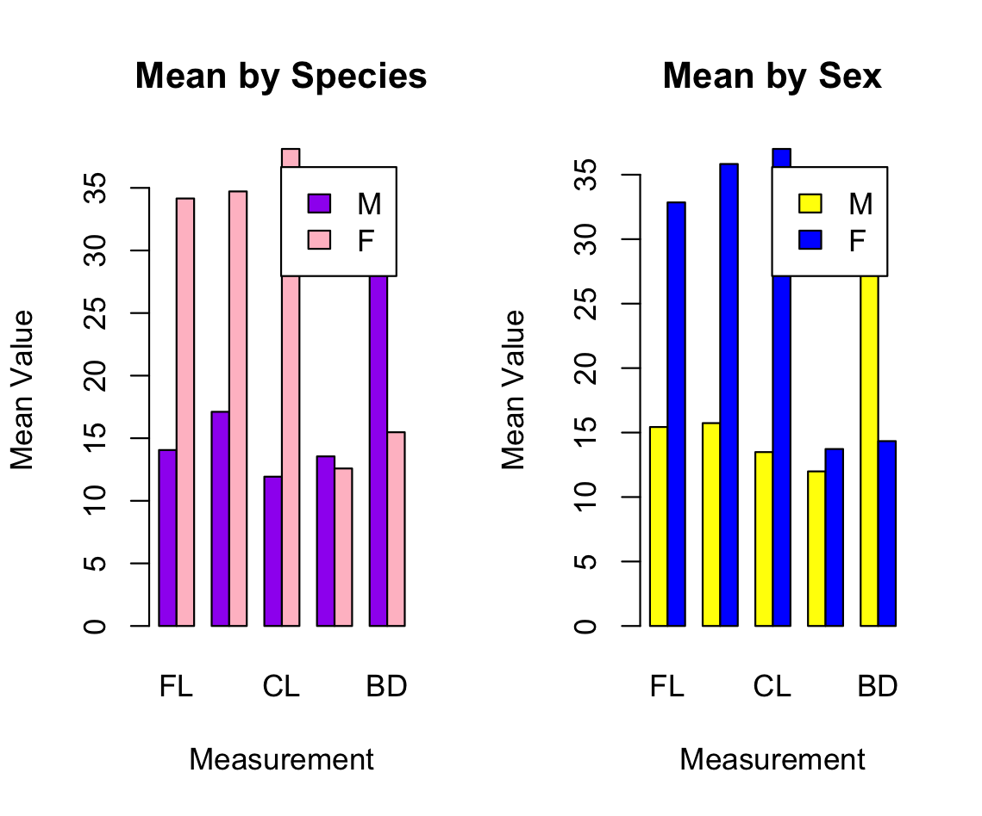

QUESTION FOUR (c)
Great species variation : The Carapace Length show the great species variation.
Least Sex variation: The Carapace Width show the least variation.

QUESTION FIVE (a)
Code:
crab_measurements<-crabs[,4:8]
pairs(crab_measurements, col= "blue", main =
"Correlation between the morphological measurements of crabs")

Output:
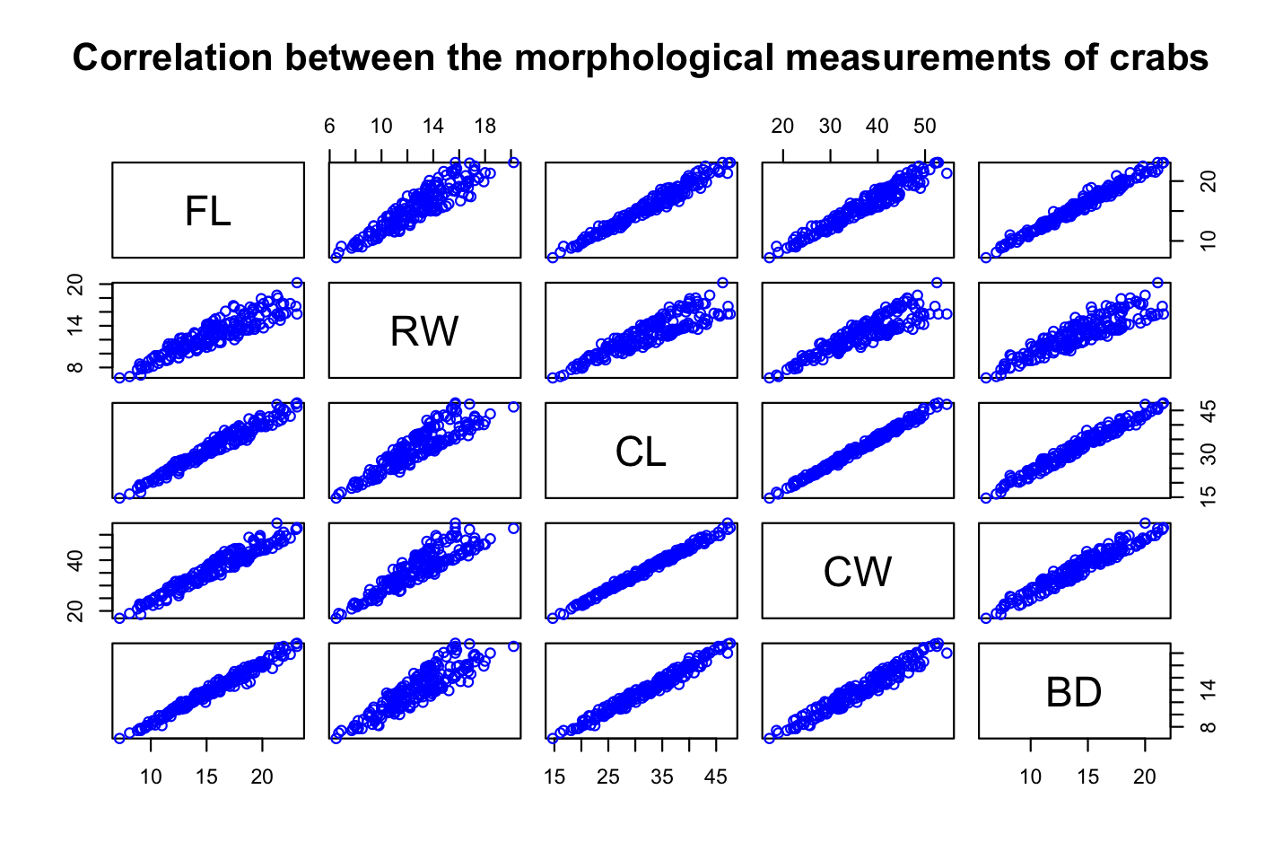

QUESTION FIVE (b)
FL AND RW
There is a strong positive relationship.
FL AND CL
There is a strong positive relationship.
FL AND CW
There is a strong positive relationship.
FL AND BD
There is a strong positive relationship.
RW AND CL
There is a strong positive relationship.
RW AND CW
There is a strong positive relationship.
RW AND BD
There is a strong positive relationship.
CL AND CW
There is a strong positive relationship.
CL AND BD
There is a strong positive relationship.
CW AND BD
There is a strong positive relationship.

QUESTION SIX
The report analyzes morphological measurements of 200 crabs collected in Fremantile, Australia, examining variations between species and sex.
Findings
The dataset had a balanced dataset with 100 blue crabs, 100 orange crabs, 100 female crabs and 100 male crabs.
Major Observations
- Orange crabs are consistently larger than Blue crabs across all measurements
- Greatest species variation: Carapace Length (+4.1 mm)
- Least sex variation: Carapace Width (1.2 mm difference)
- All morphological measurements show strong positive correlations (r > 0.8)
- Distributions are approximately normal with minimal outliers
Conclusion
Orange crabs are larger than blue crabs while sex-based differences are smaller.

